**EBS Volume creation and attchement in the Instance:-**

1**.Created EC2 Instance and EBS volume attached to the Instance**

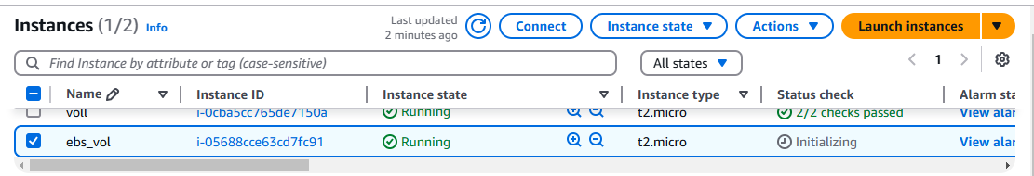

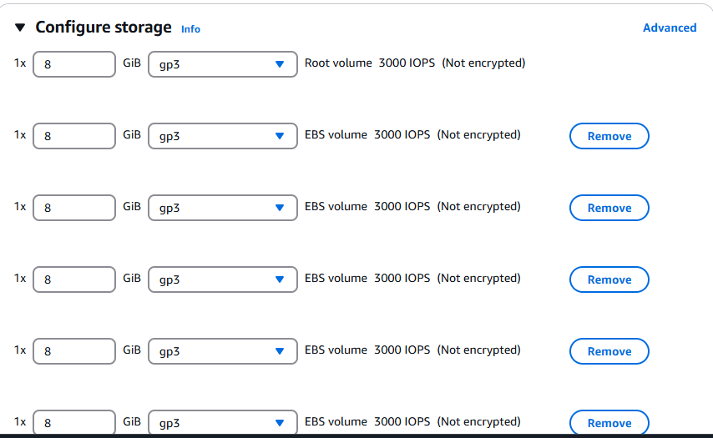

2.**Attached EBS volume to the instance**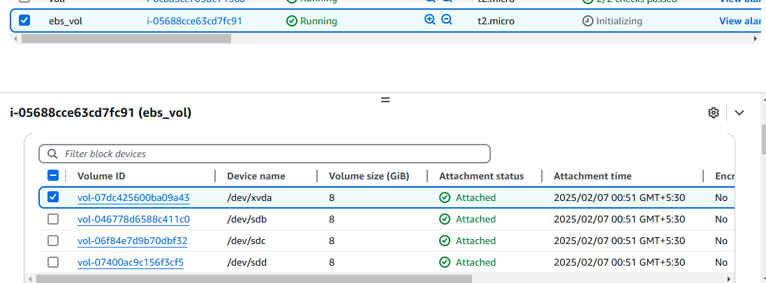

**3.Now we will attach EBS volume to the instance via CLI**

**Commnd df -h …> used to check the disc space**

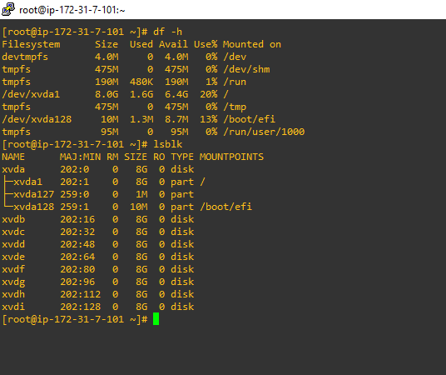

**4. file -s 🡪 We will see if something is here in the disc, whether the volume has a filesystem, is empty, or has raw data.**



**5. Using command mkfs -t ext4 /dev/xvdb --🡪Now we will format the hard disc before mounting on to the directory**

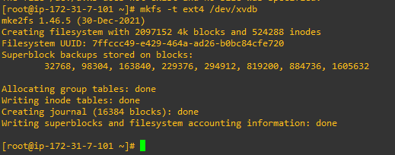

**6. We will make directory named with Java_app to mount the volume in the directory**



**7. Now we will mount Volume to directory Java_app**

**Use command -🡪 mount /dev/xvdb java_app**

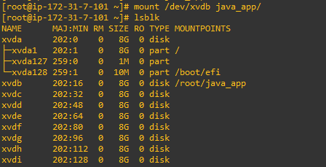

**8. Attached another volume via GUI**

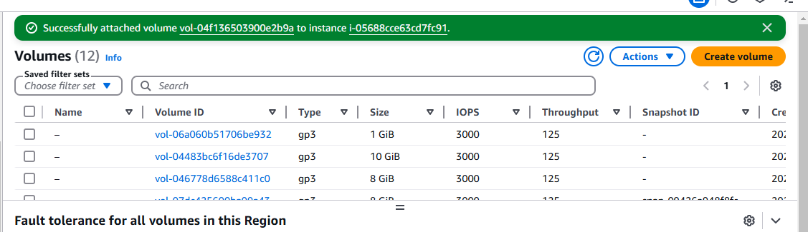

--

🡪**How to create snapshot manually**

1. Manually Via GUI

1.**First, we will create a EC2 instance as below, I named it Lamda_EC2**

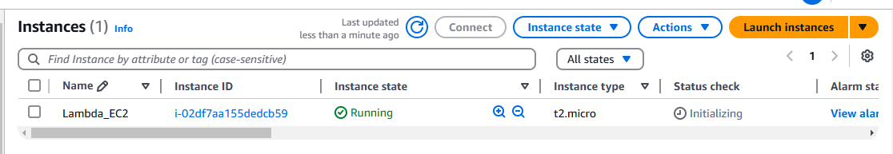

2.Go to the Volume section and search for Instance Vol with Instance

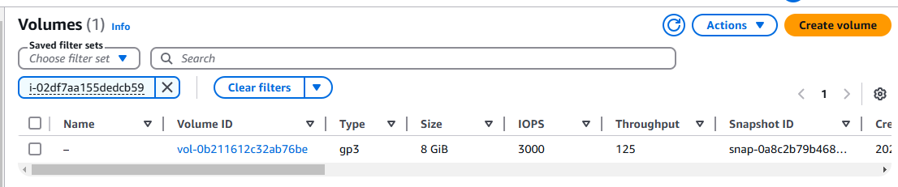

3.Create snapshot from the volume and named accordingly

